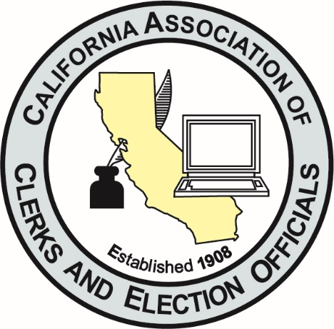
Dear Association Members:

We’d like to personally welcome each of you to the California Association of Clerks & Election Officials 113th Annual Conference. This virtual conference will be July 12-15, 2021 and hosted by Shasta County. Conference hosts have assembled a terrific slate of speakers and educational sessions for the conference. Empowering Change.
It’s an exciting time for CACEO as we continue to grow, remaining always adaptable, motivated and responsive. Our members are confronting a time of many changes, they are meeting those changes head-on, and are continuing to meet and conquer change.
Our members and partners have continued to meet the challenges of the job and to excel despite setbacks. We should all be very proud of where we are today and excited about where we are headed.
Throughout the conference, we ask you to stay engaged, come ready to ask questions & participate. Thank you to Shasta County for your efforts and making this happen.
Chrissi
Chrissi Keller
CACEO Conference Coordinator

Donna
Donna Johnston
CACEO President
Sutter County Clerk-Recorder, Registrar of Voters, Ex-Officio Clerk of the Board

