County Recorders’ Association of California
110th Annual & New Law Conference
1st Virtual Conference
December 14-15, 2020

California Association of Clerks & Election Officials
1st Virtual New Law Conference
December 16-17, 2020

Agenda

“THE YEAR TO FORGET”

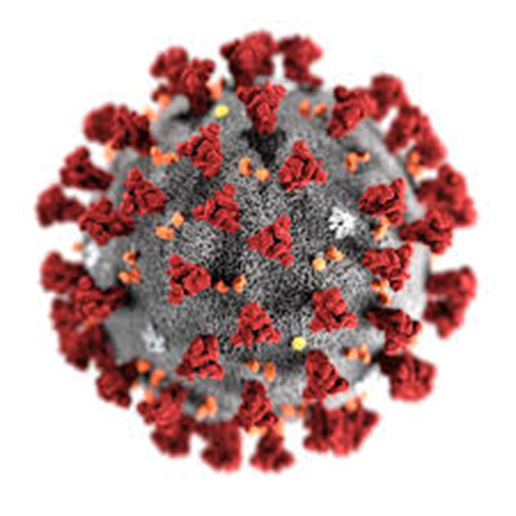

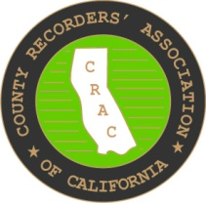
County Recorders’ Association of California
110th Annual & New Law Conference
1st Virtual Conference
December 14-15, 2020

MONDAY – 14th

8 – 9 CRAC Principals only VIRTUAL BREAKFAST

10 CRAC Legislative Meeting
- Co-chair, Monique Blakely, Los Angeles County
- Co-chair, David Valenzuela, Ventura County
- Rob Grossglauser, Legislative Advocate

10:30 DRIM Committee Meeting
- Co-chair, Danielle Rifilato, Santa Barbara County
- Co-chair, Jaime Pailma, Los Angeles County

11 CRAC Board of Directors Meeting
- President, Mark Lunn, Ventura County
- Vice President, Donna Allred, Sacramento County
- Treasurer, Leslie Morgan, Shasta County
- Secretary, Rebecca Turner, Calaveras County
- Treasurer Report
- By Laws Committee

TUESDAY – 15th

9 Exhibitor Introductions
- Exhibitor presentation
- Gift drawings

10 Recorders’ General/Opening Session
- Pledge of Allegiance
- Roll Call
- President’s Message
- Committee Reports

10:45-11 Break

TUESDAY – 15th CRAC Continued:

11 New Law Presentation
- Monique Blakely, Los Angeles County
- David Valenzuela, Ventura County
- Rob Grossglauser

11:30 Mutual Problems
- Jaime Pailma, Los Aneles County
- Danielle Rifilato, Santa Barbara County

ADJOURN

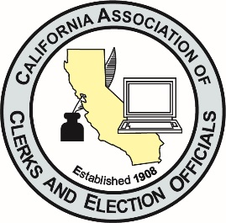

California Association of Clerks & Election Officials
1st Virtual New Law Conference
December 16-17, 2020

WEDNESDAY, 16th

  - CACEO Principals only VIRTUAL BREAKFAST

9:30-10:30 COUNTY CLERK Legislative Committee
- Co-chair, Donna Allred, Sacramento County
- Co-chair, Val Handfield, Contra Costa County
- Matt Siverling, Legislative Advocate

COUNTY CLERK – CRM Meeting
- Co-chair, Monique Blakely, Los Angeles County
- Co-chair, Jaime Pailma, Los Angeles County

9-11 ELECTIONS Legislative Committee
- Co-chair, Ryan Ronco, Placer County
- Co-chair, Tricia Webber, Santa Cruz County

WEDNESDAY – 16th CACEO Continued

11-12 CACEO Board of Directors Meeting
- President, Brandi Orth, Fresno County
- Vice President, Donna Johnston, Sutter County
- Treasurer, Tommy Gong, San Luis Obispo County
- Secretary, Michael Vu, San Diego County

1-2 ELECTIONS – Voters with Specific Needs (closed to vendors)
- Co-chair, Tim McNamara, Los Angeles County
- Co-chair, Eren Mendez, Contra Costa County

2-3 ELECTIONS – Fiscal Staff Workshop (closed to vendors)
- Cathy Darling Allen, Shasta County

THURSDAY, 17th

8:30-9:30 CACEO Exhibitor Introductions
- Exhibitor Presentation
- Gift drawing

9:30-10:45 CACEO General Session
- Pledge of Allegiance
- Roll Call
- President’s Message
- Committee Reports

10:45-11 Break

11-11:30 COUNTY CLERK – New Law Presentations
- Donna Allred, Sacramento County
- Val Handfield, Contra Costa County

11:30-12:30 ELECTIONS – New Law Presentations
- Ryan Ronco, Placer County
- Tricia Webber, Santa Cruz County

11:30-1 COUNTY CLERK – Mutual Problems
- Val Handfield, Contra Costa County
- Donna Allred, Sacramento County

1-5 ELECTIONS – BPC Meeting (open to BPC member counties only)
- John Gardner, Solano County

Adjourn

