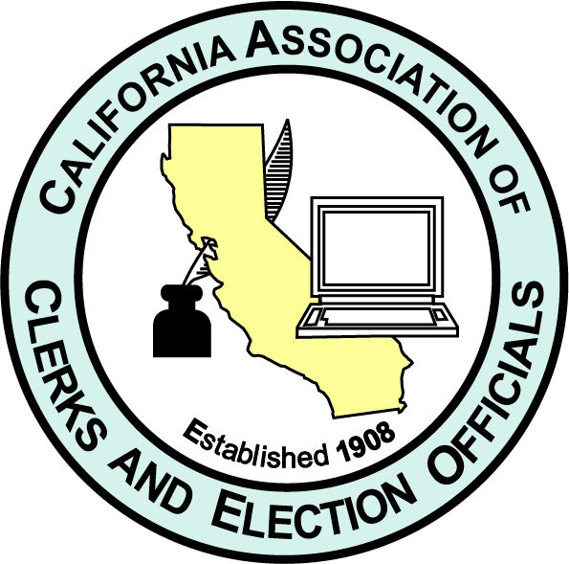
Dear Association Partners:
We’d like to personally welcome each of you to the California Association of Clerks & Election Officials 113th Annual Conference. This virtual conference will be July 12-15, 2021 and hosted by Shasta County. Conference hosts have assembled a terrific slate of speakers and educational sessions for the conference. Empowering Change.
It’s an exciting time for our members and partners as we continue to grow, remaining always adaptable, motivated and responsive. We are all confronting a time of many changes and meeting those changes head-on,
Our members and partners have continued to meet the challenges of the job and to excel despite setbacks. We should all be very proud of where we are today and excited about where we are headed.
Your registration fee provides for advertisement of your company in the conference electronic agenda, also displayed periodically during the conference, as well as giving time to vendors during the conference for introductions and remarks. The time slots will be divided by the number of registered vendors. . This would be a great time to do a company gift drawing for those attending, don’t you think?
As we get closer to the conference date more details will be provided. You must be registered and paid to receive via email, attendee list ,about 2 weeks prior and the conference access link, about 3 days prior to conference.
I do hope you are able to join us, get your profile out there and just say hello. We look forward to seeing you!
Thank you to Shasta County for their efforts to make this happen
Donna
Donna Johnston
CACEO President
Sutter County Clerk-Recorder, Registrar of Voters, Ex-Officio Clerk of the Board

Chrissi
Chrissi Keller
CACEO Conference Coordinator

