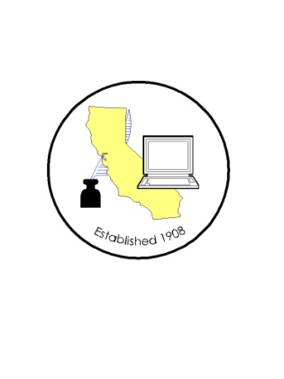 CALIFORNIA ASSOCIATION OF

CLERKS AND ELECTION OFFICIALS

January 11, 2011

TO: CACEO Members, Guests, Legislative Committee

FROM: Deborah Seiler and Jill LaVine, Co-Chairs

SUBJECT: CACEO LEGISLATIVE COMMITTEE MEETING

DATE: FRIDAY, January 14, 2011

TIME: 9:00 a.m. – 3:00 p.m.

LOCATION: County of Sacramento Administration Building
700 H Street, Hearing Room One, 1st Floor
Sacramento, CA 95814

Subcommittee Meetings, Thursday, January 13

10 am – Noon Summer Institute – Lee Lundrigan

1 pm – 3 pm Voters with Specific Needs – Tim McNamara

3pm – 5 pm HAVA/Certification/Voting Systems – Tim McNamara

FRIDAY AGENDA

9:00 am Welcome and Introductions

Approval of Minutes of December 8, 2010 meeting

Report on Postal Committee – Jill LaVine

Status Report on VBM “White Paper” – Janice Atkinson

Discussion of Bills
AB 80 SB 66
AB 84

Legislative Proposals
(Bring copies of your proposals to share with the group)
Noon Lunch (on your own)

1:00 pm Subcommittee Reports

