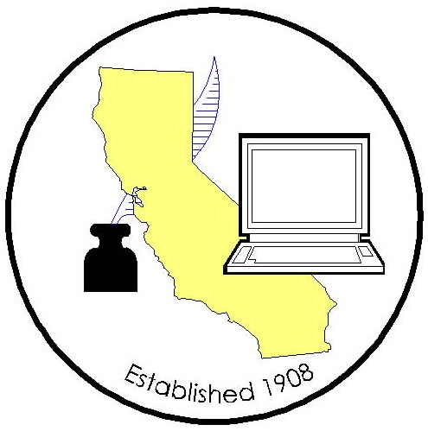

COUNTY CLERK LEGISLATIVE COMMITTEE MEETING

Meeting Date: Tuesday, July 11, 2017
Time: 10:30am -12:00 pm
Location: CACEO Conference, Lake Tahoe Resort & Hotel
Emerald Room

AGENDA
2017/2018 County Clerk Legislative Committee Members
Joe Holland, Santa Barbara |  | Joani Finwall, San Bernardino
Elizabeth Gutierrez, Contra Costa |  | Victoria Rodriguez, Riverside
Teresa Williamson, San Joaquin |  | Catherine Stefani, San Francisco
Kammi Foote, Inyo |  | Gina Alcomendras/Wardell House, Santa Clara
Portia Sanders/Monique Blakely/Jaime Pailma, Los Angeles |  | David Valenzuela/Sheila Harmon, Ventura
Chuck Storey, Imperial |  | Deva Proto, Sonoma
Olga Lobato, Marin |  | Donna Allred, Sacramento
Candace Grubbs, Butte
(P– Present; T– Teleconference; X– Not in attendance)

- Call to order

- Roll call

- Approval of minutes (June)

- Legislative advocate update

- Bill Review

- Legislative Proposals

- CRAC – crossover Legislation

8. For the Good of the Order

9. Adjourned

Note: This will not be teleconference capability for this meeting.

