THE CALIFORNIA ASSOCIATION OF CLERKS AND ELECTION OFFICIALS (CACEO)
ELECTION COSTS PROJECT

Research Brief II

Election Costs and Electoral Complexity

Electorates differ among California counties, and those differences impact the electoral process. Here we consider two communication-based differences – number of languages spoken and ability and level of speaking English – as well as a third factor, extent of residential relocation. These variables could influence the voting body’s knowledge of and commitments to elections, and potentially could affect the accuracy of voter registration lists. Externally, we draw on two sources for these measures. The first, the American Community Survey, provides estimates of the population age 5 and older who primarily speak another language at home, and who speak English less than “well”, in addition to the percent of the population who lived in a different county in the previous year. The second, the County Clerk/Registrar of Voters (CC/ROV) Memorandum #13132, identifies by county the “the number precincts where 3% or more of the voting-age residents are members of a single language minority and lack sufficient skills in English to vote without assistance”. In addition, we draw on the three CACEO election profile data items in which counties listed the languages they provide assistance for based on the Federal Voting Rights Act, Sec. 203, CA EC 12303 and 14201, or by agreements with local jurisdictions.

From these internal and external sources, we create four summary measures: the number of languages that assistance is provided for based on county reporting in the survey, the average number of languages assistance is provided for per precinct, the percent of the population who speak English less than “well”, and the percent of residents who lived in a different county the previous year. After evaluation, a number of discrepancies in language assistance measures were evident. Several counties (e.g. Los Angeles, San Bernardino, Yolo) report “N/A” for the language measures from the Election Profile part of the survey, and others had no data available. This internal source of data should be supplemented where possible with external sources for over time comparisons, which is not currently possible except for the most recent elections.

Descriptive Statistics for Electoral Complexity

Different counties face very different electorates, with some counties that provided Election Profile and cost data requiring only a single additional non-English language for ballots and materials, while others must serve voters in nine additional languages. These requirements reflect, of course, different voter populations and needs, with the fraction of the population speaking English less than well ranging from 2% to nearly one third of the county population depending on county.

2014 General Election
 | Percent of Precincts with Non-English Language | Number of Languages from CC/ROV | Percent Speaking English less Than Very Well | Number of Languages Reported in Election Profile
Mean | 48% | 3.17 | 13.5% | 2.56
Median | 38% | 2.00 | 14.6% | 2.00
Minimum | 11% | 1.00 | 2.0% | 0.00
Maximum | 100% | 9.00 | 32.1% | 9.00

As we might expect, these measures are closely related with one another. The measure from the American Community Survey, which identifies need for non-English assistance, but does not distinguish the number of language groups, is least strongly associated. In contrast, the number of languages reported in the CC/ROV memorandum might be expected to match the number of languages reported in the election profile perfectly (aside from additional languages that may be provided additionally, such as due to requests by local jurisdictions), but does not due to missing or incorrect responses in the profile.

Pearson Correlation | 2014 General Election
 | Percent of Precincts with Non-English Language | Languages from CC/ROV | Percent Speaking English less Than Very Well | Languages Reported in Election Profile
Percent of Precincts with Non-English Language | 1 | .793 | .265 | .534
Languages from CC/ROV | .793 | 1 | .543 | .727
Percent Speaking English less Than Very Well | .265 | .543 | 1 | .388
Languages Reported in Election Profile | .534 | .727 | .388 | 1

Pearson correlation coefficients tell us how consistently the value of one measure is related to the value of another measure. When the sign of the coefficient is positive, the two measures tend to increase or decrease together; when the sign of the coefficient is negative, one measure tends to go up when the other decreases. If the association is perfect (also referred to as total correlation) – the second value is always twice as large as the first value, or the second value is always the first value plus a fixed amount – the coefficient is 1.00, and we can always perfectly predict the second value from the first. A correlation coefficient of .5 or more is considered a strong association; a correlation of .3 to .5 is considered moderate, and a correlation of less than .3 is usually considered weak.

Electorate Diversity and Election Survey Cost Measures

Simple correlations of these measures suggest little association of linguistic diversity with cost per registered voter, but reasonably strong associations with cost per voting opportunity and, as can be expected, the fraction of costs identified with multi-lingual ballots or processes. The association with cost per voting opportunity, but not cost per registered voter may suggest that language diversity has stronger impacts on costs when ballots are longer or more complex, or it may be a relationship driven by the fact that, in general, larger counties are more diverse, have more complex ballots, have higher typical wages rates and labor costs, and are homes to more linguistically diverse populations. These kinds of relationships are difficult to disentangle with the number of counties for which there are data available at this time.

2014 General Election: Correlations
Pearson Correlations |  | Canvass Cost Percent | Pollworker Cost Percent | Polling Place Cost Percent | Postage Cost Percent | Ballot Printing Cost Percent | Multi-lingual Cost Percent | Provisional Ballot Processing Cost Percent | Cost per Voting opportunity | Cost Per Registered Voter
 | Percent of Precincts with Non-English Language | .087 | -.014 | .103 | -.250 | -.158 | .393 | .052 | .494 | .045
 | Non-English Languages required in at least 1 precinct | .260 | .187 | .244 | -.192 | -.331 | .425 | .359 | .637 | .065
 | % Speaking English less Than Very Well | .118 | .007 | .222 | -.076 | -.455 | .244 | .133 | .345 | .097
 | % that Lived in Different County 1 year Ago | -.272 | -.235 | -.088 | -.169 | .141 | -.173 | -.205 | -.127 | .527

The table above shows general levels of association. Below, we track the percent of costs attributable to a variety of election functions, as well as a measure of ballot complexity, found in counties with differing levels of language diversity. The bulk of reported overall costs of the elections fall into the category of ballot printing but – interestingly, the fraction of costs associated with that task decreases as more languages need to be supported. Multi-lingual cost support does increase its fraction of costs with linguistic diversity, as expected, but it accounts on average for only 2% of total direct election costs.

Languages |  | Canvass Cost Percent | Pollworker Cost Percent | Polling Place Cost Percent | Postage Cost Percent | Ballot Printing Cost Percent | Multi-lingual Cost Percent | Provisional Ballot Processing Cost Percent | Cost Per Voting Opportunity
 | 1 | 0.2% | 13.3% | 6.3% | 7.9% | 30.5% | 0.9% | 0.1% | $3,175
 | 2 | 0.1% | 13.1% | 7.1% | 8.3% | 16.1% | 0.3% | 0.4% | $6,137
 | 3-5 | 0.5% | 10.6% | 15.2% | 8.7% | 14.5% | 3.0% | 0.4% | $10,470
 | 6-9 | 0.6% | 16.2% | 10.9% | 5.4% | 13.8% | 5.4% | 0.8% | $49,383
 | Total | 0.3% | 13.2% | 9.7% | 7.7% | 20.9% | 2.2% | 0.4% | $13,480

Residential migration, on the other hand, was associated with higher costs per registered voter, but had few associations with other cost measures. The table below shows that, although residential migration is associated with higher costs per registered voter, it does not seem be associated with either higher levels of provisional ballots, which we would expect if issues of voter registration or notification were the cause. Nor does the association with voter turnout among registered voters run in the direction expected – higher rates of migration from other counties is associated with higher voter turnout, rather than the lower levels which might result from unfamiliarity with local processes, candidates or general levels of engagement. Similarly, no association with mail return rates and migration was found.

Migration from Other County | 2014 General Election
 | Cost per registered Voter | Voter Turnout | % Provisional Ballots
bottom quintile | 4.70 | 47.0% | 3.9%
2nd lowest quintile | 5.43 | 49.2% | 2.8%
middle quintile | 6.38 | 51.5% | 3.2%
second highest quintile | 7.82 | 53.6% | 2.9%
highest quintile | 8.77 | 65.3% | 2.6%
Mean across all responses | 6.61 | 53.3% | 3.1%

Electorate Complexity Associations with Other Factors Affecting Election Costs

Relative need for linguistic support and number of languages used to serve the voting population are part of a cluster of characteristics which are associated with, or may be expected to be associated with, election costs and composition. English language facility, language diversity, and language support from counties are associated with large, densely populated urban areas with multiple sub-county cities and towns, ballots with many candidates and measures, and higher typical labor costs and wage levels. They are not significantly associated with vote-by-mail or variety of hardware employed in polling places. These associations are quite robust, and persist after removing the most linguistically diverse counties, and the most densely populated counties. The joint variation of these characteristics make it difficult to parse out – at this time – individual elements and their effects on costs.

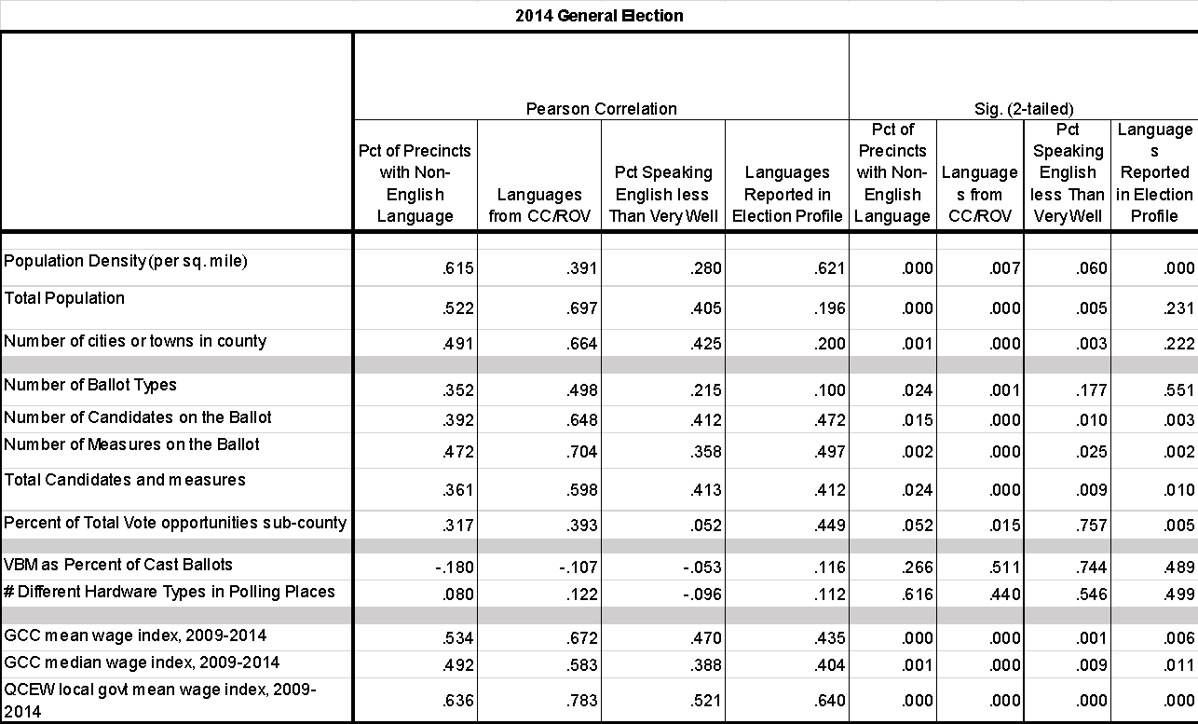

Summary conclusion:
There are external and internal measures of complexity of the electorates in terms of languages. As we might expect, these are strongly associated with each other. Through this analysis, we’ve discovered that there are cases in which counties are not completely reporting which languages they are providing services for. County conformity in regards to entering data into the survey needs to be addressed. Specifically, larger counties are failing to accurately report their language services.
We have found no strong association between linguistic complexity and cost per registered voter. Predictably, certain costs, such as those associated with multi-lingual ballots, are associated with linguistic complexity. It is likely that some effects of this are due to the association between counties with complex electorates, with many ballot types, and that contain high-density urban areas. However, it is impossible to untangle all these elements with the present available data. Further research about the causes and relationships between costs and electoral complexity may be possible as more data is collected.

Two counties – Alpine and Trinity – are not required to make ballots available in any non-English language. Neither of those counties provided Direct Costs Categories or Election Profile data for the 2014 General Election, and not included in these tables.
A Pearson correlation describes the linear relationship between 2 variables. The coefficient is between -1 and +1 where 1 is a positive correlation (or relationship), 0 is no correlation and -1 is a negative correlation.
“Voting opportunity” for the purposes of the research briefs, refers to the sum of the number of candidate contests and ballot measures. It is a county-level measure of total items for which a vote could be cast.

