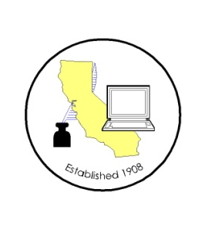
CALIFORNIA ASSOCIATION OF

CLERKS AND ELECTION OFFICIALS

August 31, 2011

TO: CACEO Members, Guests, Legislative Committee

FROM: Deborah Seiler and Jill LaVine, Co-Chairs

SUBJECT: CACEO LEGISLATIVE COMMITTEE MEETING

DATE: FRIDAY, September 9, 2011

TIME: 9:00 a.m. – 3:00 p.m.

LOCATION: County of Sacramento
799 G Street, OCIT – 2nd Floor Conference Room
Sacramento, CA 95814

Subcommittee Meetings, Thursday, September 8th

10 am- Noon Petitions – Deborah Seiler

1 pm – 3 pm Voters with Specific Needs – Tim McNamara

3 pm – 5 pm HAVA/Certification/Voting Systems – Tim McNamara

FRIDAY AGENDA

9:00 am Welcome and Introductions

Approval of Minutes of August 5th meeting

Presentation by Federal Voting Assistance Program staff

Presentation by Susan Clark

Planning for New Law Conference
CHAPTERED BILLS
AB 80 Fong (Ch. 138) AB 985 Williams (Ch. 52) AB 84 Fong (Ch. 186) AB 1343 Fong (Ch. 191) AB 193 Knight (Ch. 137) AB 1357 Swanson (Ch. 192)
AB 413 Yamada (Ch. 187) AB 1412 AER Cmte (Ch 118)
AB 459 Hill (Ch. 188)
AB 461 Bonilla (Ch. 189) SB 66 Vargas (Ch 22)
AB 506 Block (Ch. 190)
AB 754 Fletcher (Ch. 57)
BILLS ON THE GOVERNOR’S DESK
AB 293 Hill SB 88 Yee
AB 362 Lowenthal SB 183 Correa
AB 547 Gatto SB 199 Correa
SB 205 Correa
SB 327 SER Cmte

BILLS ON THE FLOOR
AB 684 Block SB 441 Vargas

Noon Lunch on Your Own

1:00 pm Subcommittee Reports

